PLACEMENT PORTAL MANAGEMENT SYSTEM

An Application Development Report Submitted
In partial fulfillment of the requirements for the award of the degree of
Bachelor of Technology In
Computer Science and Engineering
By
GUGULOTH SIRISHA 22N31A0567
GUNDAPANENI VENKATA ALEKHYA 22N31A0570
MALOTH PREMKUMAR 22N31A05C7
Under the esteemed guidance of
Dr. S. SHANTHI
Professor


Department of Computer Science and Engineering
Malla Reddy College of Engineering and Technology

(Autonomous Institution-UGC, Govt. of India)
(Affiliated to JNTUH, Hyderabad, Approved by AICTE, NBA&NAAC with ‘A’ Grade) Maisammaguda, Kompally, Dhulapally, Secunderabad – 500100
Website: www.mrcet.ac.in

2024-2025


Malla Reddy College of Engineering and Technology

(Autonomous Institution-UGC, Govt. of India)
(Affiliated to JNTUH, Hyderabad, Approved by AICTE, NBA&NAAC with ‘A’ Grade) Maisammaguda, Kompally, Dhulapally, Secunderabad – 500100
Website: www.mrcet.ac.in
CERTIFICATE
This is to certify that this is the Bonafide record of the application entitled “PLACEMENT PORTAL MANAGEMENT SYSTEM”, submitted by Student GUGULOTH SIRISHA (22N31A0567) GUNDAPANENI VENKATA ALEKHYA (22N31A0570) and MALOTH PREMKUMAR (22N31A05C7) of B.Tech in the partial fulfillment of the requirements for the degree of Bachelor of Technology in Computer Science and Engineering, Department of CSE, during the year 2024-2025. The results embodied in this application report have not been submitted to any other University or Institute for the award of any degree.

Internal Guide Head of the Department
Dr. S. Shanthi Dr. S. Shanthi
Professor Professor

External Examiner

DECLARATION

We hereby declare that the application entitled “PLACEMENT PORTAL MANAGEMENT SYSTEM” submitted to Malla Reddy College of Engineering and Technology (UGC Autonomous), affiliated to Jawaharlal Nehru Technological University Hyderabad (JNTUH) for the award of the degree of Bachelor of Technology in Computer Science and Engineering is a result of original research carried-out in this thesis. It is further declared that the application report or any part thereof has not been previously submitted to any University or Institute for the award of degree.

G SIRISHA -(22N31A0567)

G V ALEKHYA - (22N31A0570)

M PREMKUMAR-(22N31A05C7)

ACKNOWLEDGMENT

We feel honored to place our warm salutation to our college Malla Reddy College of Engineering and Technology (UGC-Autonomous) for allowing us to do this Application as part of our B. Tech Program. We are ever grateful to our Director Dr. V. S. K Reddy and Principal Dr. S. Srinivasa Rao who enabled us to have experience in engineering and gain profound technical knowledge.
We express our heartiest thanks to our HOD, Guide Dr. S. Shanthi for encouraging us in every aspect of our course and helping us realize our full potential.
We would like to thank our Class Incharge Mr. B. Sunil who despite being busy with his academic duties took time to guide and keep us on the correct path.
We would also like to thank all the faculty members and supporting staff of the
Department of CSE and all other departments who have helped directly or indirectly in making our application a success.
We are extremely grateful to our parents for their blessings and prayers for the completion of our application which gave us the strength to do our application.
With regards and gratitude

G SIRISHA -(22N31A0567)

G V ALEKHYA -(22N31A0570)

M PREMKUMAR -(22N31A05C7)

ABSTRACT

The Placement Portal Management System is a sophisticated web-based application designed to enhance and streamline the placement process within educational institutions through three core modules: Student, Staff, and Admin. The Student Module allows students to manage their placement journey by creating and updating profiles with personal details, academic records, and resumes. Students can upload and share their placement details upon securing a job, track their application status, and receive notifications about placement activities and interview schedules. The Staff Module provides faculty members and placement officers with comprehensive management capabilities, enabling them to monitor student submissions, verify placement details, download offer letters, and generate customized student lists based on academic performance and company-specific criteria. This module also facilitates efficient coordination with recruiting companies and the scheduling of interviews. The Admin Module offers full administrative control, managing user roles and permissions, modifying student academic records for data accuracy, and generating detailed reports to provide insights into placement activities. By automating key tasks and fostering effective communication among all stakeholders, the Placement Portal Management System reduces administrative burdens and enhances the overall experience for students, staff, and administrators alike.
S. NO |  | TITLE | PG. NO
1 |  | INTRODUCTION | 1
 |  | 1.1 PURPOSE, AIM AND OBJECTIVES | 2
 |  | 1.2 EXISTING AND PROPOSED SYSTEM | 4
 |  | 1.3 SCOPE OF APPLICATION | 5
2 |  | LITERATURE SURVEY | 7
3 |  | SYSTEM ANALYSIS | 9
 |  | 3.1 HARDWARE AND SOFTWARE REQUIREMENTS | 9
4 |  | SYSTEM DESIGN | 10
 |  | 4.1 DESCRIPTION | 10
 |  | 4.2 ARCHITECTURE | 13
 |  | 4.3 UML DIAGRAMS | 17
5 |  | METHODOLOGY | 23
 |  | 5.1 TECHNOLOGIES USED | 23
 |  | 5.2 MODULES DESCRIPTION | 27
 |  | 5.3 ALGORITHM | 28
6 |  | IMPLEMENTATION | 31
 |  | 6.1 SAMPLE CODE | 31
 |  | 6.2 OUTPUT SCREENS | 47
 |  | 6.3 TESTING | 47
7 |  | CONCLUSION & FUTURE SCOPE | 48
8 |  | BIBLIOGRAPHY | 49

LIST OF FIGURES

S.NO | NAME | PG.NO
4.2 | SYSTEM ARCHITECTURE | 13
4.3.1 | DATA FLOW DIAGRAM | 18
4.3.2 | USE CASE DIAGRAM | 19
4.3.3 | CLASS DIAGRAM | 20
4.3.4  4.3.5 | SEQUENCE DIAGRAM  COLLABORATION DIAGRAM | 21  22

TEST CASES 47

6.3.1 Test Case 1 choose the selection criteria 47
6.3.2 Test Case 2 Checking list of Eligible students 48
6.3.3 Test Case 3 Checking Student Details 49

LIST OF OUTPUTS

FIGURE.NO | NAME | PG.NO
6.2.1 | MAIN PAGE | 44
6.2.2 | ADMIN LOGIN PAGE | 44
6.2.3 | HOD LOGIN PAGE | 45
6.2.4 | STUDENT LOGIN PAGE | 45
6.2.5  6.2.6 | ABOUT PAGE  CONTACT US PAGE | 46  46

CHAPTER 1 INTRODUCTION
In today's competitive educational environment, institutions require robust systems to efficiently manage the placement process for their students. The Placement Portal Management System is a web-based solution built using PHP technology, tailored specifically to streamline placement-related activities. This system enhances collaboration between students, staff, and administrators, ensuring a seamless and efficient experience for all stakeholders.

Unlike traditional placement management approaches that rely heavily on manual data processing and coordination, this system offers a centralized platform with three distinct modules: Student, Staff, and Admin. The Student Module empowers students to maintain up-to-date profiles with personal details, academic records, and resumes, while also allowing them to track their placement status in real-time. The system also ensures that students are instantly notified of placement activities, interviews, and other essential updates, significantly reducing the likelihood of missed opportunities.

The Staff Module is designed to assist faculty and placement officers in managing and monitoring student submissions, verifying placement details, and generating performance-based reports. Faculty members can communicate with companies, schedule interviews, and even download offer letters, all from a single dashboard. This module provides an organized and data-driven approach to ensure that students are well-matched with potential employers, based on predefined academic or company-specific criteria.

The Admin Module serves as the backbone of the system, offering full administrative control over the platform. It allows administrators to manage user roles and permissions, ensuring that data privacy and integrity are maintained. Furthermore, admins can update student academic records to ensure accuracy and generate detailed reports that offer insights into ongoing placement activities.

With its cutting-edge PHP-based framework, the Placement Portal Management System provides features such as automated notifications, secure data handling, and customizable reporting, which greatly simplify the placement process. This system distinguishes itself from traditional placement methods by automating time-consuming tasks, fostering effective communication between students, staff, and employers, and ensuring data accuracy through constant updates. The system’s overall design is user-friendly, making it an indispensable tool for educational institutions seeking to optimize their placement management workflow.

PURPOSE AND OBJECTIVES

The purpose of the "Placement Portal Management System" application is to develop a comprehensive, web-based platform that simplifies and enhances the placement process within educational institutions. The primary aim is to provide a centralized system that streamlines the management of student placements, ensuring efficiency, transparency, and ease of communication among students, faculty, and administrators. By integrating modern web technologies, the application seeks to automate key processes related to placement activities, thereby reducing the manual workload for staff and providing a seamless experience for students.

A key objective is the development of an intuitive interface that allows students to easily manage their placement journey, from updating personal details and academic records to tracking application status and receiving real-time notifications. The system also empowers faculty members and placement officers by offering tools for monitoring student progress, verifying placement details, and coordinating with recruiting companies. Administrators are provided with full control over the system, enabling them to manage user roles, ensure data accuracy, and generate detailed reports on placement activities.

Some key objectives of the system include:
- Efficient Placement Management: Streamlining the placement process for students, staff, and administrators by providing automated tools and features.
- Real-Time Updates and Notifications: Ensuring students receive timely updates about placement opportunities, interview schedules, and application statuses.
- User-Friendly Interface: Developing an easy-to-use interface that allows quick and efficient navigation for all users.
- Role-Based Access: Ensuring proper data management and system security through role-based access for students, staff, and administrators.

• The system shall allow students to create and update their profiles with personal details and resumes.
• The system shall enable staff to verify placement details and coordinate interviews with recruiting companies.
• The system shall grant administrators full control to manage users and generate reports on placement activities

1.2 Proposed System

The Placement Portal Management System is designed to enhance and streamline the placement process within educational institutions, offering a web-based solution that integrates all key stakeholders—students, staff, and administrators—into a single platform. The system addresses several challenges faced in the traditional placement process, such as the manual handling of student profiles, scheduling, and coordination with companies. By automating these processes, the proposed system ensures increased efficiency, transparency, and accessibility for all users.

The Placement Portal Management System comes equipped with three core modules: Student, Staff, and Admin. The Student Module enables students to create and update their profiles, upload resumes, and track their placement progress in real-time. Notifications regarding placement activities, interview schedules, and updates on application status can also be easily accessed. The Staff Module is designed to assist faculty members and placement officers in monitoring student submissions, verifying placement details, and facilitating coordination with recruiters for scheduling interviews. Meanwhile, the Admin Module allows full administrative control, enabling the management of user roles, permissions, and academic records, as well as generating detailed reports on placement activities for data-driven insights.

The proposed system aims to simplify the placement process while reducing administrative burdens. By fostering seamless communication and automating key tasks, it ensures that all users, from students to administrators, can easily access and manage relevant information.

Advantages of the Proposed System
- The system enhances the efficiency of the placement process by automating manual tasks.
- It offers a centralized platform, improving communication and coordination between students, staff, and companies.
- The system is user-friendly and accessible, with a simple interface for all users.
- With its ability to track, monitor, and generate reports, the system allows for better organization and data management.
- It reduces administrative workload, allowing staff and administrators to focus on more critical tasks related to student placements.

1.3 SCOPE OF APPLICATION

The Placement Portal Management System offers a comprehensive solution to streamline and manage the placement activities of educational institution, enhancing the overall efficiency of the placement process. Its scope extends to the management of student profiles, application tracking, and coordination with companies, making it an essential tool for institutions aiming to modernize their approach to campus recruitment.

The system's scope encompasses three key modules—Student, Staff, and Admin—each designed to cater to the specific needs of its users. The Student Module allows students to create and update their profiles, upload resumes, track placement status, and receive notifications, making it easier for them to manage their placement journey. The Staff Module provides faculty and placement officers with the ability to monitor student progress, verify placement details, and generate customized lists based on academic performance and company requirements, ensuring smooth coordination with recruiters. The Admin Module offers complete administrative control, enabling management of user roles, data accuracy, and generating reports that provide valuable insights into placement activities.

The system's adaptability ensures its applicability across various types of educational institutions, from schools to universities, and is not limited to a particular department or field of study. Additionally, the portal is designed to foster easy communication and coordination between students, staff, and recruiting companies, ensuring a smooth and transparent placement process. By enabling real-time tracking and notifications, the system reduces the burden on administrators and provides students with up-to-date information on their placement progress.

The Placement Portal Management System also supports long-term scalability and can be expanded with new features, such as enhanced analytics, job market trends, or integration with external tools like interview platforms, further widening its scope. Ultimately, the system is designed to transform and optimize the campus placement process, making it efficient, user-friendly, and accessible to all stakeholders involved.

Key areas covered by the system's scope include:

- Profile Management: Enabling students to maintain detailed academic and personal information, resumes, and track placement progress.
- Coordination and Monitoring: Allowing staff to oversee and verify placement activities, ensuring seamless communication with recruiters.
- Administrative Control: Providing tools for data management, report generation, and system-wide oversight to administrators.

This broad scope ensures that the Placement Portal Management System is an essential tool for improving the efficiency and effectiveness of campus placements, benefiting students, staff, and administrator

CHAPTER 2
LITERATURE SURVEY

The development of the Placement Portal Management System is informed by an extensive body of research on various components that are central to managing the placement process in educational institutions. A wide range of studies and papers provide valuable insights into the evolution of web-based management systems, student information systems, and recruitment coordination frameworks, all of which have contributed to the understanding and design of this system.

"A Survey on Student Information Systems" (Journal of Educational Technology & Society, Vol 22, March 2017)

This paper reviews the design and implementation of student information systems (SIS) used in educational institutions to manage student data and academic records. The study highlights the importance of SIS in streamlining administrative processes, including enrollment, course management, and record keeping, which are crucial for maintaining accurate placement data. The paper also discusses the integration of such systems with external platforms to facilitate better communication between students, faculty, and recruiters. The insights from this study provide the foundation for the Student Module of the Placement Portal, which manages student profiles and academic records.

"Web-Based Systems for Recruitment Management: A Survey" (International Journal of Computer Applications, Vol 128, June 2016)

This survey explores various web-based systems designed for recruitment management, focusing on how these platforms enable the coordination between educational institutions and companies. The paper emphasizes the role of such systems in improving the efficiency of campus recruitment by automating job postings, resume submission, and interview scheduling. The survey’s findings underline the necessity of creating a centralized platform where students, staff, and companies can interact seamlessly. This research directly informs the design of the Placement Portal’s Staff Module, which enables faculty and placement officers to coordinate interviews, track student applications, and interact with recruiters.

"Automating Placement Activities Using Web Portals: A Case Study" (IEEE Access, Vol 6, July 2018)

This case study delves into the challenges faced by educational institutions in managing placement activities manually and discusses the advantages of automating these tasks through web portals. It highlights the impact of automation on reducing administrative burdens, improving data accuracy, and enhancing the overall experience for students and staff. The study's findings emphasize the importance of features like real-time notifications, application tracking, and automated reporting, all of which are incorporated into the Placement Portal Management System to streamline the placement process and provide real-time updates.

"Role of Cloud-Based Solutions in Student and Placement Management" (ACM Computing Surveys, Vol 50, January 2019)

This paper examines the use of cloud-based technologies in managing educational data, including placement activities. It highlights the scalability, flexibility, and security benefits of cloud-based systems, which are increasingly used in educational institutions for managing student information and placement data. The findings of this study have informed the design of the Placement Portal’s backend architecture, ensuring that it is scalable and secure, particularly in handling large volumes of data related to student profiles, academic records, and company interactions.

"Enhancing Student Engagement in Placement Processes through Technology" (Journal of Higher Education Policy and Management, Vol 42, April 2020)

This research focuses on how technology can enhance student engagement in the placement process by providing better access to information, improving communication channels, and offering personalized services. The study underscores the importance of user-friendly interfaces and real-time data access, which improve the overall experience for students navigating the placement process. These insights have directly influenced the design of the Placement Portal’s user interface, ensuring it is intuitive and accessible for students of varying technical expertise.

CHAPTER 3

SYSTEM ANALYSIS

System requirements are the functionality that is needed by a system in order to satisfy the customer's requirements. System requirements are abroad and a narrow subject that could be implemented to many items. The requirements document allows the application team to have a clear picture of what the software solution must do before selecting a vendor. Without an optimized set of future state requirements, the application team has no effective basis to choose the best system for your organization
3.1 HARDWARE AND SOFTWARE REQUIREMENTS
3.1.1 HARDWARE REQUIREMENTS
• Minimum 4 GB RAM
• Minimum 500 GB Hard Disk
• Minimum i3 processor or equivalent

3.1.2 SOFTWARE REQUIREMENTS
• OS: Windows or Linux
• Web Browser (Chrome, Firefox, etc.)
• PHP (Server-side scripting)
• MySQL (Database management)
• Apache Server (Web server)
• HTML/CSS/JavaScript (Front-end technologies)
• Python (for additional data processing or automation)

CHAPTER 4

SYSTEM DESIGN

4.1 DESCRIPTION
System design is the process of creating the architecture, components, and interfaces of a system to ensure that it satisfies user requirements and meets functional and non-functional needs. In the case of the Placement Portal Management System, the system is designed to automate and streamline the placement activities of educational institutions, focusing on user interaction, data management, and efficient communication between students, staff, and administrators.
PHP TECHNOLOGY
PHP (Hypertext Preprocessor) is a widely-used open-source scripting language specifically designed for web development. It can be embedded into HTML and is well-suited for building dynamic and interactive web applications. PHP plays a crucial role in this application by enabling server-side functionality, managing interactions with databases, and generating dynamic content for the Placement Portal Management System.
PHP allows us to build interactive pages where users such as students, staff, and administrators can perform tasks like managing profiles, uploading resumes, verifying placement details, and generating reports. PHP is chosen for this application because of its simplicity, versatility, and widespread use in web development. Moreover, its compatibility with databases, easy integration with HTML, and support for various frameworks make it an ideal choice for building a robust and scalable placement portal.
SYSTEM DESIGN
The system is designed using the Model-View-Controller (MVC) architecture, which separates the application logic into three core components:
- Model: This handles the data logic of the system, including the interaction with the database. In this system, PHP interacts with a MySQL database to store and retrieve data related to student profiles, job listings, interview schedules, and placement results.
- View: This handles the presentation layer and is responsible for rendering the user interface. Using PHP in conjunction with HTML and CSS, the system provides an intuitive and user-friendly interface for students, staff, and administrators to interact with the portal.
- Controller: This manages the logic that connects the user input to the model and the view. It processes requests from users (e.g., profile updates, job applications) and interacts with the model to update the database, then sends the results back to the view for display.
MODULES
The Placement Portal Management System comprises the following primary modules:
- Student Module:
  - Allows students to create and manage their profiles by adding personal information, academic records, and uploading resumes.
  - Students can apply for job opportunities, track application status, and receive notifications about interview schedules.
- Staff Module:
  - This module allows placement officers and faculty to manage student submissions, verify academic details, download offer letters, and track placement activities.
  - Faculty can also generate lists of eligible students based on various criteria and coordinate with companies to schedule interviews.
- Admin Module:
  - The Admin module provides overall administrative control, managing user roles, permissions, and overseeing all activities within the portal.
  - Admins can modify student data, monitor the system’s performance, and generate reports for analysis.
DATABASE DESIGN
The system uses a MySQL database for data storage and management. The database contains multiple tables for storing information such as:
- Student information (personal details, academic records, resumes)
- Job listings and descriptions
- Interview schedules and results
- Company details and offers
- System logs for audit and tracking
Relational database principles are employed, with tables designed to maintain referential integrity and ensure efficient querying and updating of data.
SYSTEM INTERACTION FLOW
- Student Interaction: A student logs into the system using their credentials. Once authenticated, they are presented with options to update their profile, upload documents, view job opportunities, and track their placement status. PHP handles the request by interacting with the MySQL database and retrieving relevant data for the student.
- Staff Interaction: Placement officers access the system to review student profiles and job applications. They can verify records and generate reports. PHP facilitates this by processing form submissions and updating the database as required.
- Admin Interaction: The administrator can manage the entire system by creating or modifying roles, updating records, and overseeing the overall performance of the platform.
PERFORMANCE CONSIDERATIONS
To ensure optimal performance, PHP is used in conjunction with caching mechanisms to reduce database load during peak usage times (e.g., during placement periods). Pagination is implemented to manage large data sets efficiently, ensuring quick response times.
SECURITY
Security is a critical aspect of the system. PHP implements session management to control user access, and role-based access control (RBAC) ensures that only authorized users can access specific functionalities. Sensitive data like student profiles and placement results are encrypted, and secure authentication methods (e.g., hashed passwords) are employed to protect user accounts.
SCALABILITY
To handle increased traffic and growing data volume over time, the system can be scaled by distributing the load using cloud infrastructure. PHP’s lightweight nature and compatibility with various hosting solutions make it suitable for scaling up without compromising performance.

SYSTEM ARCHITECTURE

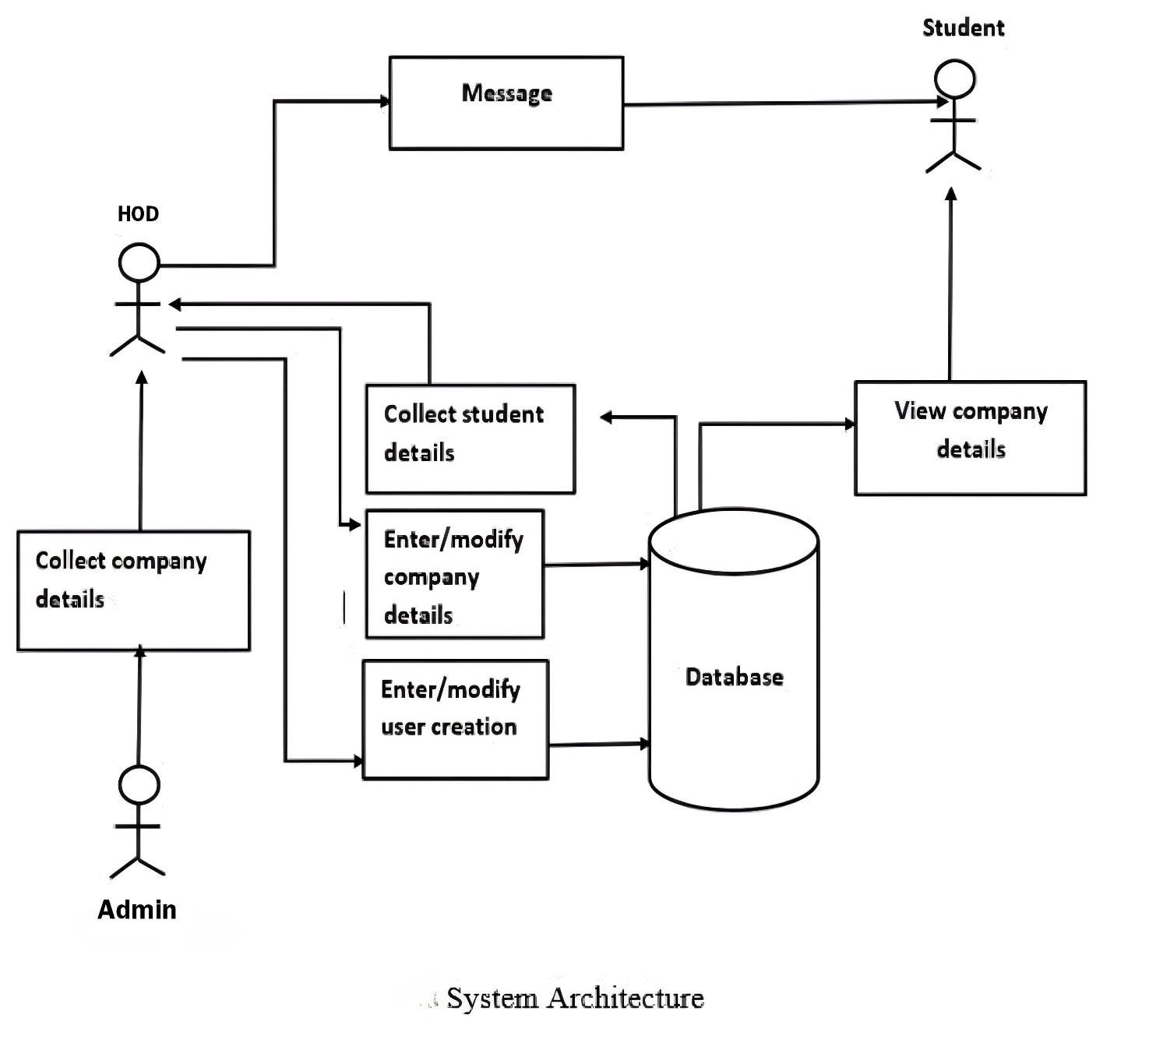

This Architecture demonstrates the working of the Placement Portal Management System, which optimizes and streamlines the placement process in educational institutions. The system begins by creating and updating student profiles, including personal information, academic records, and resumes. Once a profile is established, students can track their application status, upload resumes, and receive notifications regarding placement activities and interview schedules. The system further facilitates communication by allowing students to share their placement details upon securing a job.
Faculty members and placement officers, through the Staff Module, can verify student submissions, monitor the placement activities, download offer letters, and generate custom student lists based on academic performance and other relevant criteria. This module also coordinates with recruiting companies to schedule interviews and track the progress of student applications.
The Admin Module ensures full administrative control, allowing for the management of user roles and permissions. Admins can also modify student academic records to ensure data accuracy and generate reports to analyze the overall placement activities. The system's automation of key processes significantly reduces administrative burdens.
This web-based application is designed with a user-friendly interface, enabling efficient interaction for users of all levels of technical expertise. It ensures real-time communication between students, staff, and recruiters while maintaining data integrity and security. Furthermore, the system’s compatibility with modern web platforms ensures accessibility across various devices, allowing for ease of use from any location. This architecture not only enhances operational efficiency but also provides valuable insights into placement activities, benefiting both the institution and its stakeholders.

INPUT DESIGN
Input design is a crucial step in software development, requiring meticulous attention to ensure the accuracy and efficiency of data input into the system. For the Placement Portal Management System, input screens are a vital part of every module (Student, Staff, and Admin), ensuring the smooth operation of the system. Proper input design minimizes errors while feeding data, guiding users to enter valid and accurate information.
The input design for this system converts user inputs into a format that can be processed by the application. Inputs are made logical and straightforward, ensuring data accuracy. Validations are embedded into each form field, ensuring that incorrect entries trigger error messages and prompt the user to correct mistakes before proceeding. This process ensures error-free data entry and seamless user interaction.
Each module of the system requires specific input forms:
- Student Module Input Design:
  - Students enter personal details, academic records, and upload resumes.
  - Forms guide the student through fields such as name, contact details, academic scores, and achievements.
  - Validations ensure that mandatory fields are completed, formats (such as email addresses and phone numbers) are correct, and the uploaded documents meet the specified criteria (e.g., file size and format).
- Staff Module Input Design:
  - Placement officers input and verify student placement details.
  - Forms allow staff to search student records, verify academic details, and generate reports.
  - Validation ensures that all fields are accurately filled, preventing incomplete or incorrect information from being submitted.
- Admin Module Input Design:
  - Administrators input data related to user management, system settings, and placement statistics.
  - Forms ensure that administrative tasks such as modifying academic records, assigning user roles, and generating placement reports are accurately completed.
User-friendly Input Forms:
- The forms have been designed to be intuitive, with clear labels and helpful hints.
- Drop-down lists and radio buttons are used where multiple options are available, helping users select the correct input quickly.
- Error messages alert the user when they attempt to input invalid data, guiding them to the correct format or missing fields.
OUTPUT DESIGN
Output design is critical to facilitating effective communication between students, placement officers, and administrators in the Placement Portal Management System. The outputs from the system are designed to provide meaningful, actionable information in a user-friendly and efficient manner.
The output of the system is designed to meet the requirements of the different user roles:
- Student Module Output Design:
  - Students receive notifications and updates regarding their placement status, upcoming interviews, and any changes in the placement process.
  - The output includes downloadable offer letters, interview schedules, and status reports, which are presented in a clear, organized manner.
- Staff Module Output Design:
  - Placement officers receive detailed reports on student performance, placement progress, and interview schedules.
  - The output includes generated lists of eligible students, downloadable reports, and placement status updates, all presented in a format that facilitates easy monitoring and decision-making.
- Admin Module Output Design:
  - Administrators receive system reports, user management information, and data analytics.
  - The output includes system performance reports, detailed logs of placement activities, and analytics on the success of placements, all formatted for easy comprehension and analysis.
Output Formats:
- The output is designed to be presented in both visual and textual formats, ensuring clarity and ease of understanding.
- Charts, graphs, and tables are used to represent complex data such as placement statistics, offering a quick overview of trends and performance.
- All outputs are designed to be downloadable, allowing users to save reports or logs for offline access or further analysis.
User Interaction with Outputs:
- Outputs are accessible through the system’s dashboard, where each user role has personalized access to the relevant outputs.
- Output screens are organized in a manner that highlights key information, with drill-down options for users who need more detailed data.

4.3 UML DIAGRAMS
Unified Modeling Language (UML) diagrams are graphical representations used in software engineering to visualize the structure, behavior, and interactions of a system. These diagrams help in understanding, designing, and communicating the system's architecture and functionality among stakeholders. UML diagrams can be categorized into several types, including structural diagrams such as class diagrams, object diagrams, and component diagrams, which depict the static structure of the system, including classes, objects, and their relationships. On the other hand, behavioral diagrams such as sequence diagrams, activity diagrams, and state diagrams illustrate the dynamic behavior and interactions within the system, showcasing how components collaborate to achieve specific functionalities. Additionally, deployment diagrams depict the physical deployment of software components across hardware nodes, while use case diagrams provide a high-level view of the system's functionalities from the user's perspective. Each UML diagram serves a specific purpose in capturing different aspects of the system, and collectively they offer a comprehensive representation of the system's architecture, behaviour, and interactions.

1. Data Flow Diagram

A data-flow diagram is a visual representation of how data moves through a system or a process (usually an information system). The data flow diagram also shows the inputs and outputs of each entity as well as the process itself. A data-flow diagram lacks control flow, loops, and decision- making processes. With a flowchart, certain operations based on the data can be depicted. The flowchart can be used to understand how the data flows in this application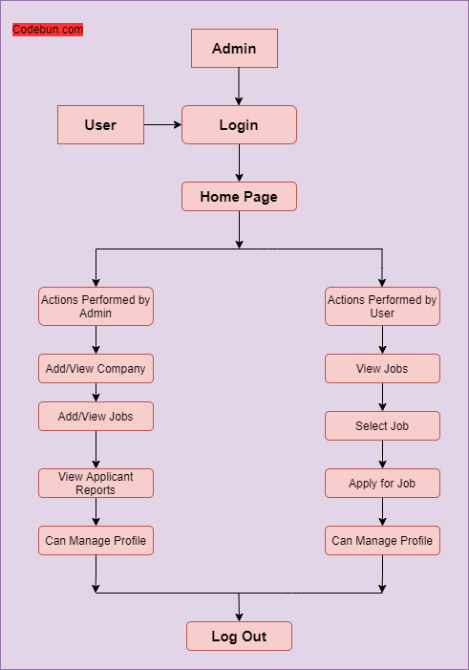

Fig. Data Flow Diagram

2. Use Case Diagram
To depict a system's dynamic behavior, use case diagrams are often employed. Using use cases, actors, and their interactions, it captures the functionality of the system. A system or subsystem of an application's necessary duties, services, and operations are modelled. It shows a system's high- level functionality as well as how a user interacts with that system.

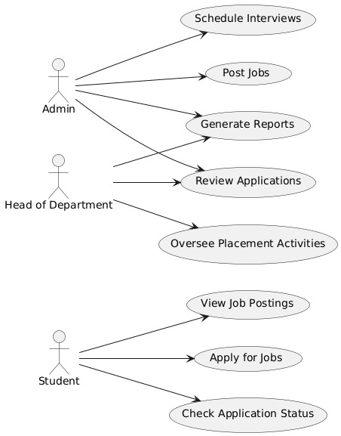

Fig. Use Case Diagram

3. Class Diagram
Class diagrams are the main building block of any object-oriented solution. It displays a system's classes, along with each class's properties, operations, and relationships to other classes. Most modelling tools include three elements to a class. Name is at the top, followed by attributes, then operations or methods, and finally, methods. Classes are linked together to generate class diagrams in a complex system with numerous related classes. Various sorts of arrows represent different relationships between classes.
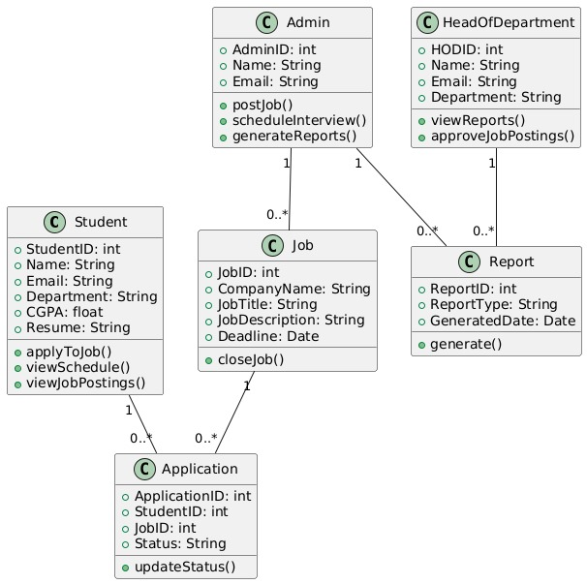

Fig. Class Diagram

4. Sequence Diagram
In UML, sequence diagrams display how and in what order certain items interact with one another. It's crucial to remember that they depict the interactions for a certain circumstance. The interactions are depicted as arrows, while the processes are portrayed vertically. The objective of sequence diagrams and their fundamentals are explained in this article. To understand more about sequence diagrams, you may also look at this comprehensive tutorial.
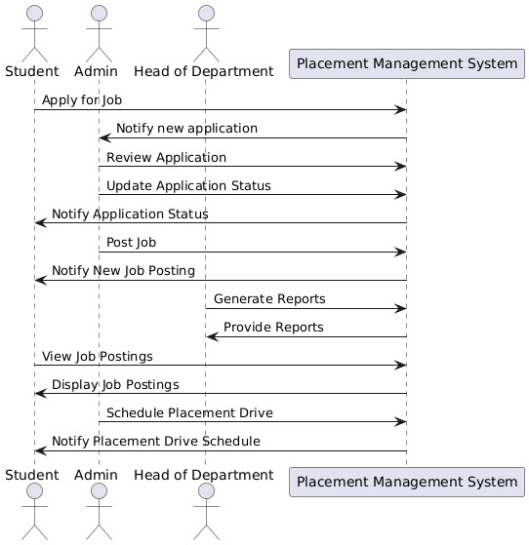
Fig. Sequence Diagram

5.Collaboration Diagram
In UML, **collaboration diagrams** (also known as communication diagrams) display the interactions between objects or components in a system, highlighting the structural organization of the entities involved. These diagrams focus on the relationships and message flow between objects to accomplish a specific task. In a collaboration diagram, objects are represented as rectangles, and the interactions between them are shown as labeled arrows. The interactions are numbered to indicate the sequence of messages.
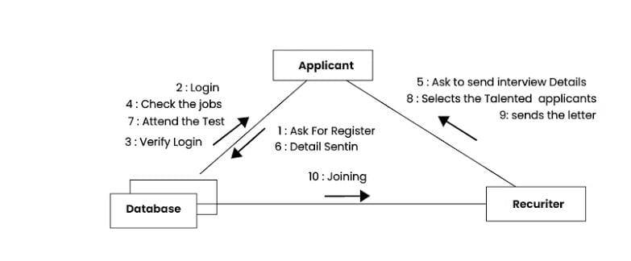

Fig. Collaboration Diagram
CHAPTER 5

METHODOLOGY

5.1 TECHNOLOGIES USED

5.1.1 PHP

PHP (Hypertext Preprocessor) is a popular open-source server-side scripting language designed for web development. It is known for its efficiency in handling server-side tasks, such as interacting with databases, processing forms, and managing user sessions.

Usage in the Application:
- In the Placement Portal Management System, PHP serves as the backbone for the server-side logic. It handles user authentication (login/logout), processes the form submissions for students, staff, and admin, and communicates with the MySQL database to fetch or store data such as student profiles, placement records, and interview schedules.
- PHP scripts are used to execute dynamic content, ensuring the system can generate and display real-time information such as student applications, placement updates, and notifications.
- The flexibility of PHP allows for the easy integration of features like uploading student resumes, verifying placement data, and generating dynamic reports for administrators.

Key Features & Benefits:
- Server-Side Scripting: Executes commands on the server before sending the output to the client, making it ideal for backend tasks.
- Database Integration: Easily integrates with MySQL to perform database operations like retrieving and updating records.
- Open Source & Community Support: Being open-source, PHP has a large community and extensive libraries that facilitate rapid development.
- Platform Independent: PHP runs on any major operating system, ensuring the application is flexible and widely compatible.

5.1.2 JavaScript

JavaScript is a versatile client-side scripting language widely used to create dynamic and interactive web pages. It plays a crucial role in enhancing the user experience by allowing real-time interactions without needing to refresh the page.

Usage in the Application:
- In the Placement Portal Management System, JavaScript is used to handle client-side operations, such as validating form inputs before submission (e.g., checking that all required fields are filled), updating parts of the page dynamically using AJAX (such as when a student updates their profile), and providing real-time feedback to users.
- JavaScript is also employed in the creation of interactive elements like dashboards, real-time notifications, and confirmation dialogues, improving the overall user experience for students, staff, and admin.
- AJAX (Asynchronous JavaScript and XML) is particularly important for updating sections of the web page without reloading, such as when students track their placement application status or staff verifies student submissions.

Key Features & Benefits:
- Client-Side Execution: Runs directly in the browser, making it ideal for creating fast, responsive interfaces.
- Interactivity: Enables dynamic features like interactive forms, pop-up notifications, and real-time content updates.
- AJAX Integration: Allows partial page updates, which improves performance and user experience by reducing the need to reload entire pages.
- Cross-Browser Compatibility: JavaScript works across different browsers, ensuring consistent functionality.

5.1.3 HTML

HTML (Hyper Text Markup Language) is the standard language for creating the structure of web pages. It defines the elements that make up a web page, such as headings, paragraphs, forms, tables, and buttons.

Usage in the Application:
- HTML is used throughout the Placement Portal Management System to create the layout and structure of each web page. It forms the base for the front-end user interface, ensuring that students, staff, and administrators can easily navigate and interact with the system.
- Each module (Student, Staff, Admin) has a distinct interface designed using HTML, ensuring that users can view and input data into forms, see listings of placement opportunities, or review student profiles.
- HTML forms the foundation for all input fields, tables displaying placement status, and navigation elements within the portal, ensuring that content is organized and accessible.

Key Features & Benefits:
- Content Structure: Defines the layout and organization of a web page, ensuring proper formatting and navigation.
- Semantic Markup: Enables the use of tags that clearly define the purpose of content, such as forms, tables, headings, and lists.
- Cross-Platform Compatibility: HTML pages work seamlessly across different devices and browsers, ensuring a consistent user experience.

5.1.4 CSS

CSS (Cascading Style Sheets) is a language used to control the presentation and styling of HTML elements. It allows developers to separate content structure from design, ensuring that web pages are visually appealing and consistent.

Usage in the Application:
- In the Placement Portal Management System, CSS is used to style all the HTML elements and create a clean, modern, and user-friendly interface. It ensures that the web application is visually attractive, with a responsive design that works across various devices (desktop, tablet, mobile).
- CSS handles the layout, fonts, colors, and spacing across the system, ensuring that forms, tables, and buttons are styled uniformly. This enhances readability and makes navigation easier for users.
- CSS media queries are also used to implement a responsive design, ensuring that the layout adapts to different screen sizes, which is particularly important for students and staff accessing the portal from mobile devices.

Key Features & Benefits:
- Design & Layout: Controls the look and feel of the application, enhancing user experience through consistent styling.
- Responsive Design: Ensures the web application works seamlessly on different devices, from large desktop monitors to small smartphone screens.
- Separation of Content & Style: Enables developers to maintain a clean codebase by separating the structure (HTML) from the design (CSS), making updates easier.

5.1.5 MySQL

MySQL is an open-source relational database management system that enables the storage, management, and retrieval of structured data. It uses SQL (Structured Query Language) to perform operations on databases.

Usage in the Application:
- MySQL serves as the database for the Placement Portal Management System, managing the data for all three modules (Student, Staff, Admin). It stores critical information such as student profiles, academic records, placement details, and company information.
- SQL queries are used to fetch data from the database, allowing students to view their application status, staff to verify placement details, and admins to generate reports.
- MySQL ensures data consistency and security by handling user authentication, managing permissions, and ensuring that only authorized users can modify or access sensitive data.
- The system uses MySQL to perform efficient data operations like updating student placement status, retrieving lists of eligible students for specific job roles, and managing company records for placements.

Key Features & Benefits:
- Data Storage & Retrieval: Provides a powerful way to store structured data and query it using SQL, ensuring data is accessible and manageable.
- Relational Database: Supports relationships between different tables, making it easier to link data such as students with their placement records or companies with job offers.
- Scalability & Performance: Can handle large datasets efficiently, making it suitable for a system with potentially many users and large amounts of data.
- Security & Integrity: Offers features like user authentication, data encryption, and permissions, ensuring the system is secure and reliable.

MODULES DESCRIPTION

5.2.1 Student Module
- Registration & Profile Management: Students can register and create personalized profiles, including essential information such as personal details, academic records, skills, certifications, and upload their resumes.
- Job Application: Enables students to browse and filter job opportunities based on their interests and eligibility. They can apply directly to the listed jobs through the portal.
- Application Status Tracking: Students can track the progress of their applications, including statuses like applied, shortlisted, interview scheduled, selected, or rejected.
- Notifications & Announcements: Provides students with real-time notifications and updates regarding upcoming recruitment drives, deadlines, and important announcements from the placement office.
- View Placement Statistics: Offers insights into past placement records, allowing students to analyze trends and understand the hiring process better.

5.2.2 Staff Module
- Student Profile Verification: Staff members can access, review, and verify student details and resumes to ensure eligibility for different job roles.
- Job Posting Management: Facilitates the creation and management of job postings, including setting eligibility criteria, job descriptions, and recruitment timelines.
- Interview Scheduling: Enables staff to schedule interviews with students and recruiters, ensuring smooth coordination and communication.
- Recruiter Coordination: Allows staff to communicate with company representatives regarding job openings, eligibility criteria, and recruitment schedules.
- Generate Reports: Supports the generation of reports on student placements, job openings, and company participation for further analysis.

3. Admin Module
- User Management: Admins have the authority to manage user accounts, including creating, updating, and deleting accounts for students, staff, and recruiters.
- System Configuration: Provides options to configure portal settings, such as deadlines, eligibility parameters, and role-based access controls.
- Manage Recruiters & Companies: Allows the addition of new company profiles, updates on job roles, and ensures effective collaboration between companies and students.
- Placement Tracking & Analysis: Enables tracking of placement activities, monitoring student application progress, and gathering feedback from recruiters.
- Reports & Analytics Dashboard: Features an analytics dashboard to visualize placement statistics, company participation trends, and student performance metrics, aiding in data-driven decision-making.
5.3 ALGORITHM
1. User Authentication Algorithm in PHP
User authentication is a critical algorithm in the Placement Portal Management System (PPMS), ensuring secure access to the platform by validating user credentials. This algorithm handles user login and session management, providing different access levels for students, staff, and admin.

Authentication Process:
- Input Validation: When a user enters their credentials (username and password), the PHP algorithm begins by sanitizing the inputs to prevent SQL injection and other security vulnerabilities.
- Password Hashing: The system stores passwords securely using hashing algorithms like bcrypt or SHA-256. When a user attempts to log in, the entered password is hashed and compared to the stored hashed password in the MySQL database.
- Querying the Database: A MySQL query is used to fetch the corresponding record based on the username. If the username exists and the password matches, the authentication process is successful.
- Session Management: Once authenticated, PHP initiates a session for the user. The session ID is stored on the server, and a cookie is created in the user’s browser to track the session. The session ensures users stay logged in while accessing different modules of the portal, with access privileges determined by the user role (student, staff, admin).
- Security: The algorithm includes mechanisms to handle multiple failed login attempts, such as CAPTCHA or account locking, to prevent brute-force attacks.
Outcome: Successful authentication grants users access to their dashboard based on their role, while failed authentication prompts a login retry or error message.
2. Database Query Optimization Algorithm in MySQL
In the Placement Portal Management System (PPMS), efficient data retrieval and management are essential to handle large datasets involving students, placements, and recruiter information. A crucial algorithm used for optimizing MySQL queries ensures that data access remains fast and responsive, especially when handling multiple simultaneous requests.

Query Optimization Process:
- Indexing: MySQL indexing is a key technique used to speed up database queries. The algorithm automatically identifies frequently queried fields such as student IDs, recruiter names, or placement dates and creates indexes for them. This allows MySQL to retrieve rows more efficiently, bypassing full table scans.
- Query Caching: The system employs query caching, where frequently executed queries and their results are stored temporarily. When the same query is executed again, the results are fetched directly from the cache, reducing the load on the database.
- Normalization: The database schema is normalized to eliminate redundant data and ensure optimal data storage. However, in certain cases, denormalization is applied to minimize the number of JOIN operations and reduce query complexity.
- Prepared Statements: MySQL queries in PHP use prepared statements to improve security and performance. Prepared statements help prevent SQL injection attacks and optimize query execution by allowing MySQL to reuse compiled query plans for repeated execution with different parameters.
- Pagination: To handle large datasets, pagination techniques are used in MySQL queries. Instead of fetching all records at once, the algorithm retrieves a subset of data (e.g., 20 rows at a time), minimizing memory consumption and improving load times.
Outcome: The query optimization algorithm ensures efficient data retrieval, even when handling large datasets, improving the overall user experience for students, staff, and admins interacting with the Placement Portal.

CHAPTER 6

IMPLEMENTATION

6.1 SAMPLE CODE

mainpage.html

<!DOCTYPE html5>
<html>

<head>
<title></title>
<link type="text/css" rel="stylesheet" href="stylesheet.css">
</head>

<body>
<div id="header">
<!--historyden.com-->
<h3 style="color:black;"><img src="mrcet.jpg" style="float:left;width:55px;height:55px;">PLACEMENT PORTAL MANAGEMENT<img src="mrcet.jpg" style="float:right;width:55px;height:55px;"></h3>
</div>
<div id="footer">
<ul>
<li><a href="sidebar.html" target="frame"><font size=4 face="arial">Home</font></a></li>
<li><a href="about.html" target="frame"><font size=4 face="arial">About</font></a></li>
<!--<li><a href="index.html" target="frame">Help</a></li>-->
<li><a href="contact.html" target="frame"><font size=4 face="arial">Contact Us</font></a></li>
</ul>
<h3 style="font-size:25px"> </h3>
</div>

<div class="main" >
<iframe height="100%" width="100%" name="frame" src="sidebar.html">
</iframe>
</div>

<!--<div id="footer">
<ul>
<li><a href="">About</a></li>
<li><a href="">Careers</a></li>
<li><a href="">Help</a></li>
<li><a href="">Contact us</a></li>
</ul>

</div>-->

<!--duplicate-->

</body>
</html>
Pacementfile.php
<?php
include 'config.php';
// mysql_select_db();
session_name("staff");
session_start();
if(!isset($_SESSION["loggedin"]) || $_SESSION["loggedin"] != true){
header("location: staff_login.php");
exit;
}
$regdno=$_POST['id1'];
//$regdno = $_GET['num'];
$sql = "select * from package where id ='$regdno'";
$result = ($conn->query($sql));
$row = [];
if ($result->num_rows > 0) {
$row = $result->fetch_all(MYSQLI_ASSOC);
}

?>
<!DOCTYPE html>
<html lang="en">
<head>
<title>student profile</title>
<link type="text/css" rel="stylesheet" href="stylesheet.css">
</head>
<body>
<div id='student'>

<p style="text-align:right;">
<a href="staff_logout.php" class="button" align='right'><img src="signout.jpg" alt="signout" width="20" height="20"></a>
</p>
<h1 align="center">STUDENTS DETAILS</h1><br>
<table border='0' cellspacing="0" align="center" style="background: color #757575;font-size: 15px;">
<?php
if(!empty($row))
foreach($row as $rows)
{
echo $rows['file'];
?>
<tr>
<?php
echo "<td rowspan='6'>" . "<a href=".$rows['file'].' width=100px height="100px">getfile</a>' . "</td>";?></tr>
<?php } ?>
</table><br><br>

</div>
</body>
</html>

<?php
mysqli_close($conn);
?>

stylesheet.css

body {

background-color: #fff;
margin: 0px;
font-family: Verdana, Georgia, serif;
font-size: 14px;
font-size:80%;
height:100%;
border:0px;
width:100%;
}

#header {

font-size: 80%;
margin: 0px;
border:0px;
height: 10.5%;
display:flex;
justify-content: center;
flex-wrap:nowrap;
}

#navbar {
background-color:#5c755e;
font-size: 90%;
height:7.5%;
margin:0px;
text-align:center;
}

#navbar ul{
margin: 0px;
text-align:center;
list-style-type:none;
padding:5px;
border-radius: 5px;
}

.main {
background-color:white;

font-size: 110%;
height:82%;

}

#footer{
background-color:#5c755e;
padding:1px;
height:7%;
clear:both;/*protects from left and right sidebars to overcome on the footer*/
color:#000;
text-align:center;
font-size:90%;
}

#footer ul{

text-align:right;
list-style-type:none;
padding-right:20px;
border-radius: 1px;

}

#footer ul li{
display:inline;
text-align:center;
}

#footer ul li a {
text-decoration:none;
font-family:arial;
padding: .2em 1em;
color:#fff;
border-radius:5px;
}

#footer ul li a:hover {
color:#000;
font-weight:bold;
background-color:#fff;
}

.button {
text-decoration:none;
font-family:arial;
padding: .2em 1em;
color:rgb(0, 0, 0);
border-radius:5px;
}

.button:hover {
color:rgb(50, 29, 82);
font-weight:bold;
background-color:#fff;
}

h1 {
font-size: 120%;
color: #ce282e;
}

h2 {
font-size: 120%;
color: darkblue;
}

h3{
font-size:400%;
text-align:center;
color:#e5e4d7;
font-family:"century gothic","gill sans",arial,serif;
margin:0px; /*as here this h3 is inheriting the margin fron header selector ,so here we overridded it by making it zero*/

/*the below code is used to align the text vertically*/
position:relative;
top:50%;
-webkit-transform:translateY(-50%);
-ms-transform: translateY(-50%);
transform: translateY(-50%);
}
/*we can also use comments like " // statements -->; " */

.sidebar {
height: 100%;
font-family: 'Trebuchet MS', 'Lucida Sans Unicode', 'Lucida Grande', 'Lucida Sans', Arial, sans-serif;
width: 0;
position: fixed;/* Stay in place */
z-index: 1;/* Stay on top */
top: 0;
left: 0;
background-color: #f7f7f7;
overflow-x: hidden;/* Disable horizontal scroll */
padding-top: 50px;
transition: 0.2s;/* 0.2 second transition effect to slide in the sidebar */
}

#myInput {
height: 23px;
width: 90%;
}

#main1 {
position: relative;
text-align:center;
display: flex;
margin: 0 auto;
flex-wrap: wrap;
align-items: center;
font-family: 'Trebuchet MS', 'Lucida Sans Unicode', 'Lucida Grande', 'Lucida Sans', Arial, sans-serif;
}

#data {
position: relative;
top: 50%;
text-align:center;
}

/* The sidebar links */
.sidebar a {
padding: 8px 8px 8px 3px;
text-decoration: none;
font-size: 20px;
color: black;
display: block;
transition: 0.2s;
}

/* When you mouse over the navigation links, change their color */
.sidebar a:hover {
color: #5b09b9;
}

/* Position and style the close button (top right corner) */
.sidebar .closebtn {
position: absolute;
top: 0;
right: 10px;
font-size: 36px;
margin-left: 50px;
}

/* The button used to open the sidebar */
.openbtn {
font-size: 15px;
cursor: pointer;
background-color: rgb(31, 173, 38);
color: white;
padding: 10px 15px;
border: none;
}

.openbtn:hover {
background-color: rgb(10, 92, 35);
}

/* Style page content - use this if you want to push the page content to the right when you open the side navigation */
#main1 {
transition: margin-left .5s;
align-items: center;
/* If you want a transition effect */
}
@import url('https://fonts.googleapis.com/css?family=Allura|Josefin+Sans');

*{
margin: 0;
padding: 0;
box-sizing: border-box;
}

<!--body{
background: #00FFFF;
font-family: 'Times New Roman', sans-serif;
}-->

.wrapper{
margin-top: 10%;
}

.wrapper h1{
font-family: 'Allura', cursive;
font-size: 52px;
margin-bottom: 60px;
text-align: center;
}

.team{
display: flex;
justify-content: center;
width: auto;
text-align: center;
flex-wrap: wrap;
}

.team .team_member{
background: #fff;
margin: 5px;
margin-bottom: 50px;
width: 300px;
padding: 20px;
line-height: 20px;
color: #8e8b8b;
position: relative;
}

.team .team_member h3{
color: #008080;
font-size: 26px;
margin-top: 50px;
}

.team .team_member p.role{
color: #ccc;
margin: 12px 0;
font-size: 12px;
text-transform: uppercase;
}*/

.team .team_member .team_img{
position: absolute;
top: -50px;
left: 50%;
transform: translateX(-50%);
width: 100px;
height: 100px;
border-radius: 50%;
background: #fff;
}

.team .team_member .team_img img{
width: 100px;
height: 100px;
padding: 5px;
}

6.2 OUTPUT SCREENS

6.2.1 Main page

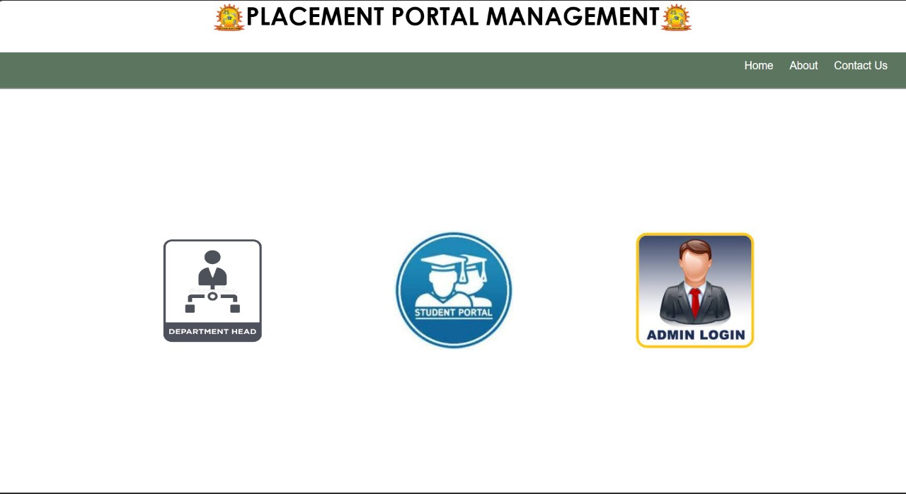

6.2.2 Admin Login Page

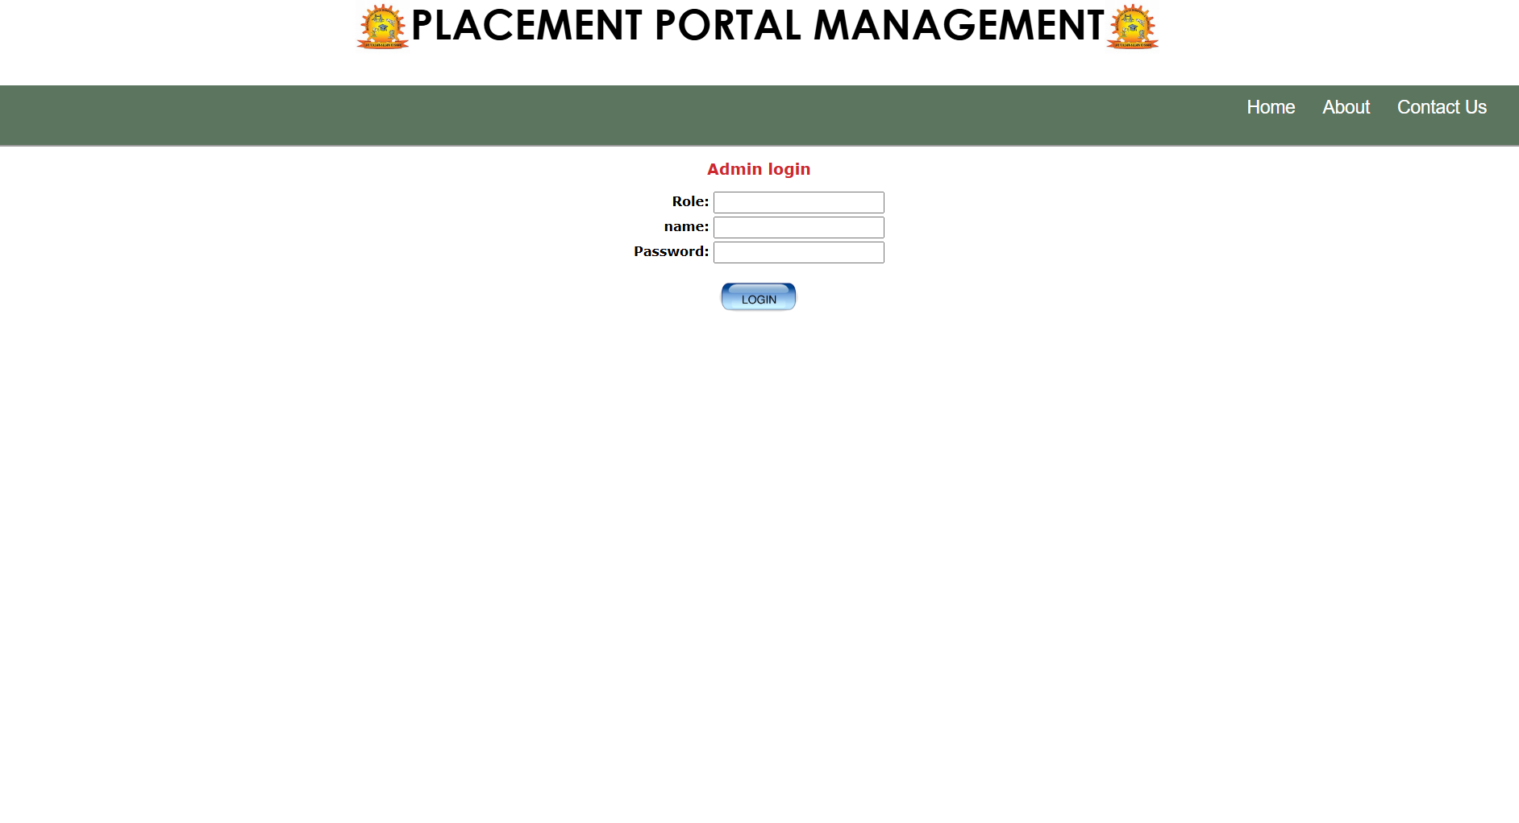

6.2.3 Hod login page

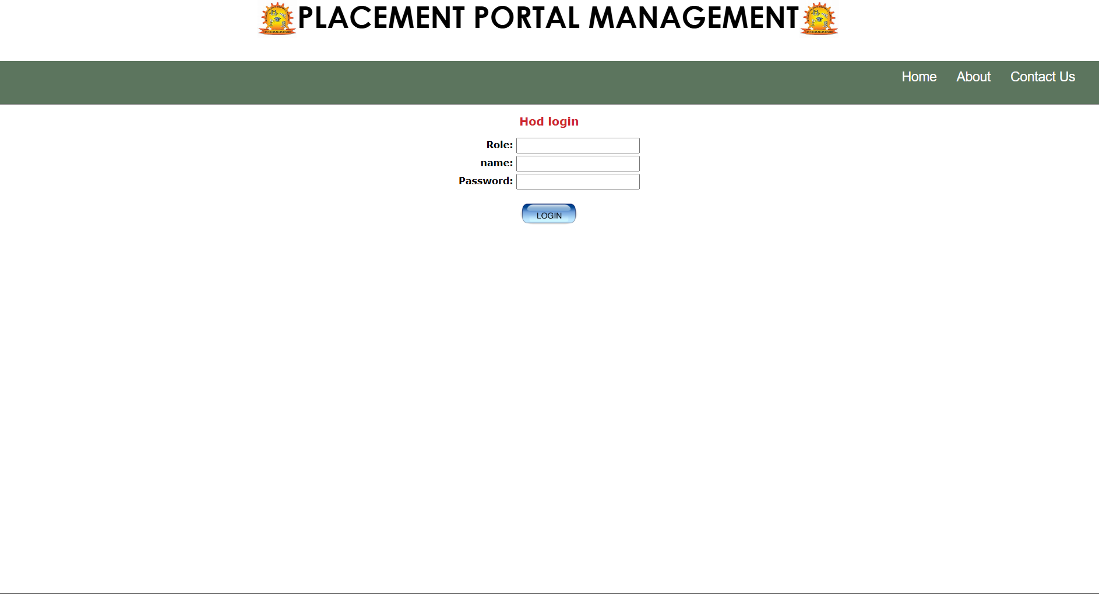

6.2.4 Student Login Page

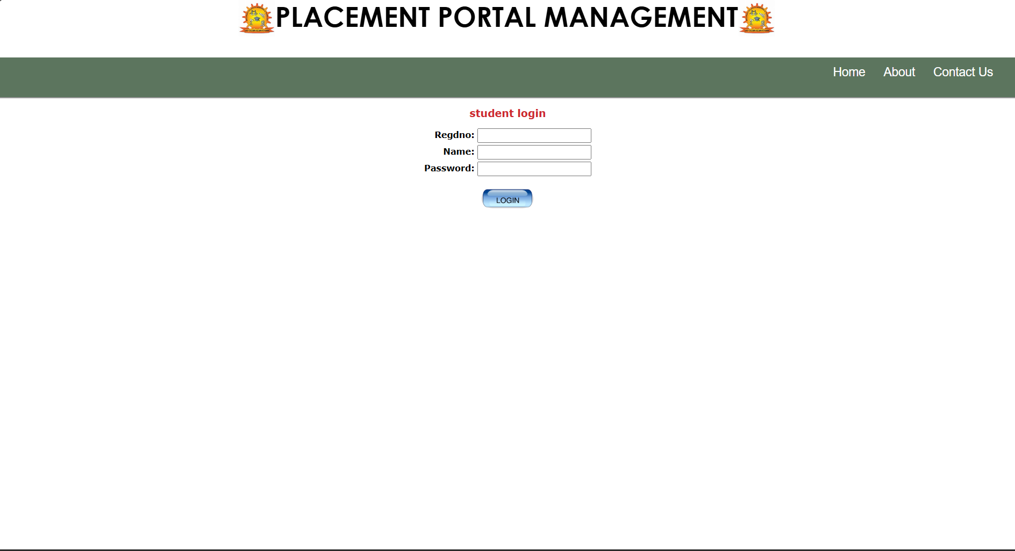6.2.5 About Page

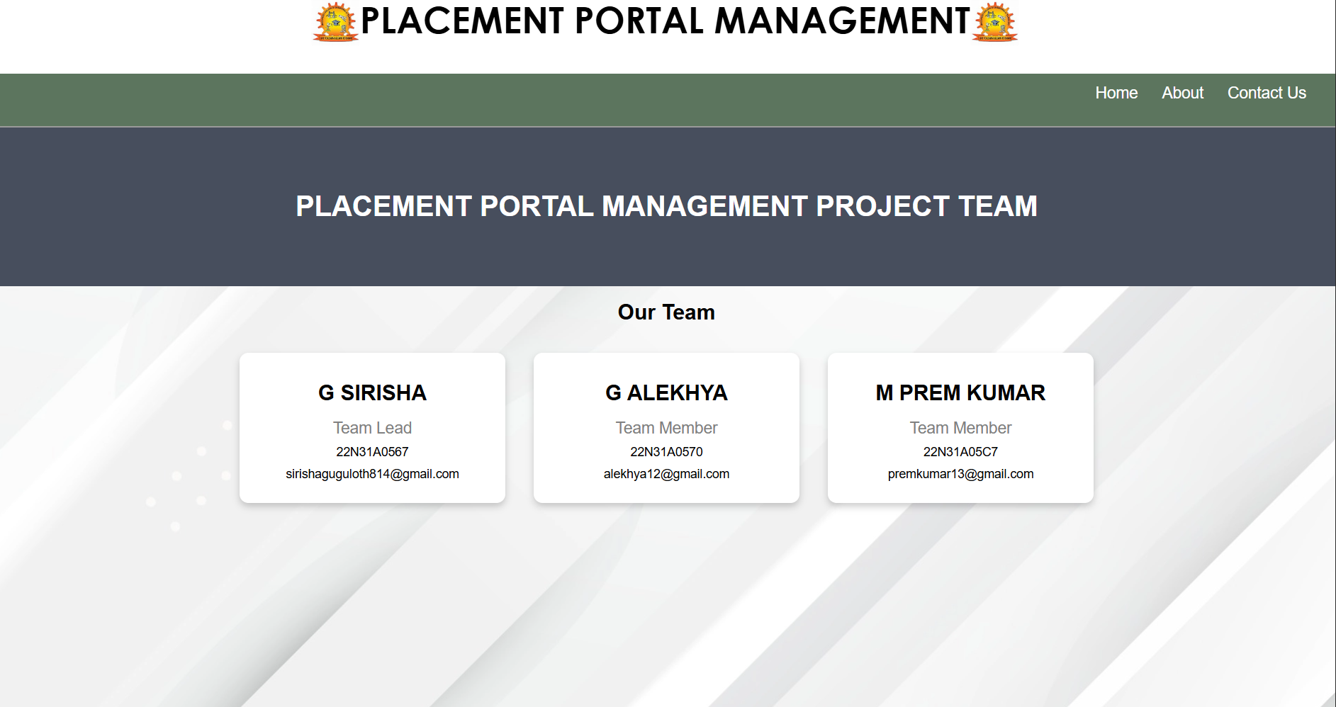

6.2.6 Contact Us Page

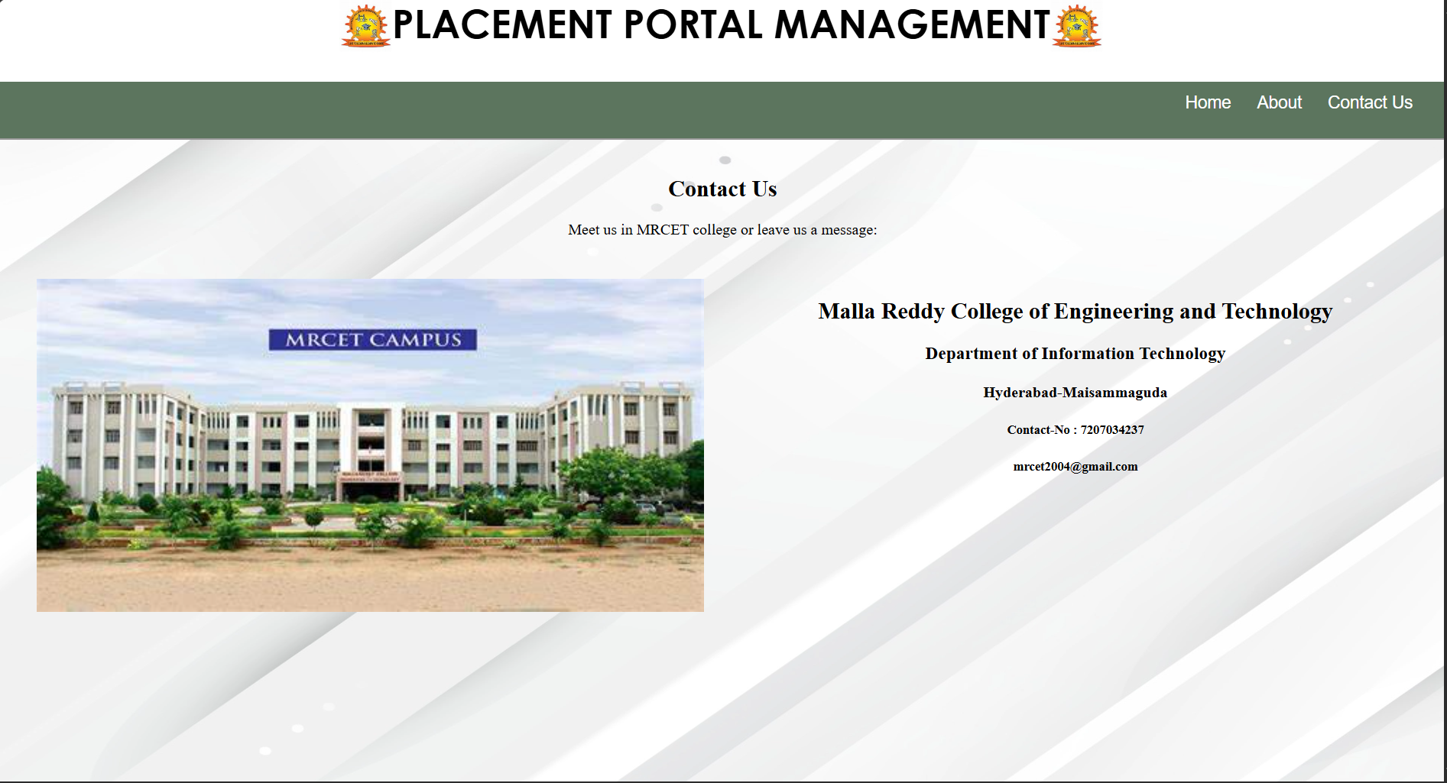

6.3 TESTING

6.3.1 Test case 1: Choose the selection criteria

6.3.1.1 Input

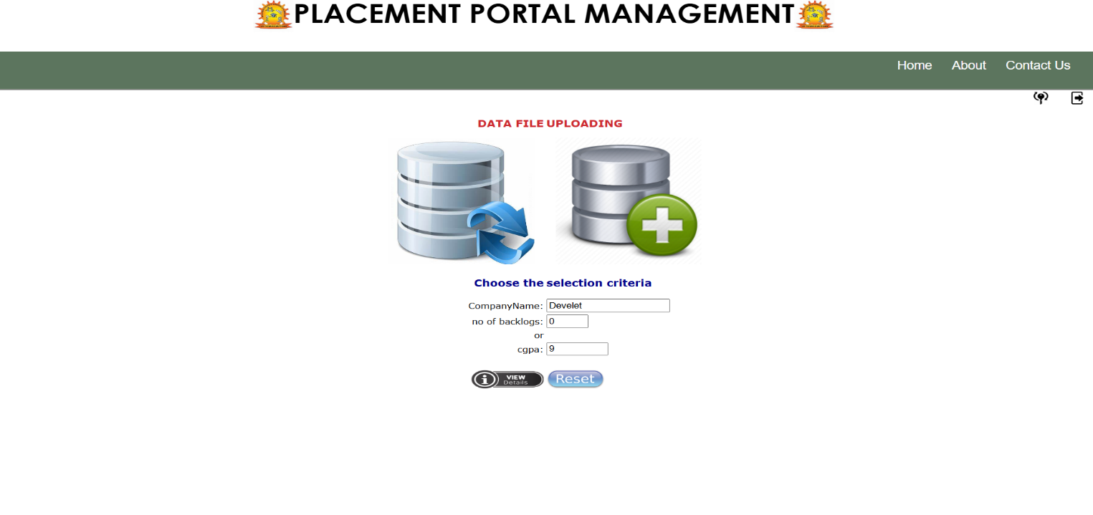6.3.1.2 Output

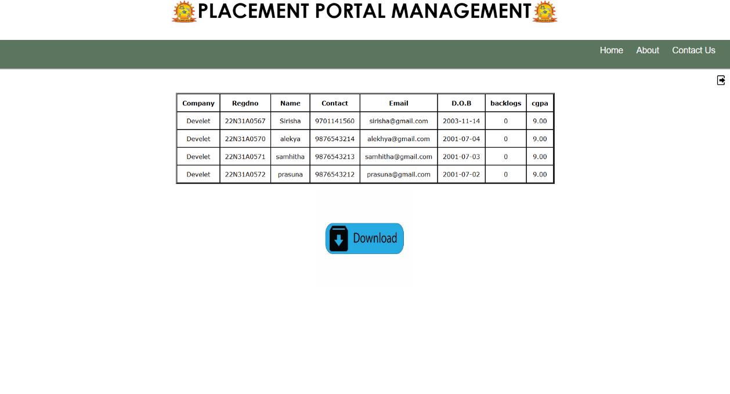

6.3.2 Test Case 2: Checking list of Eligible students

6.3.2.1 Input
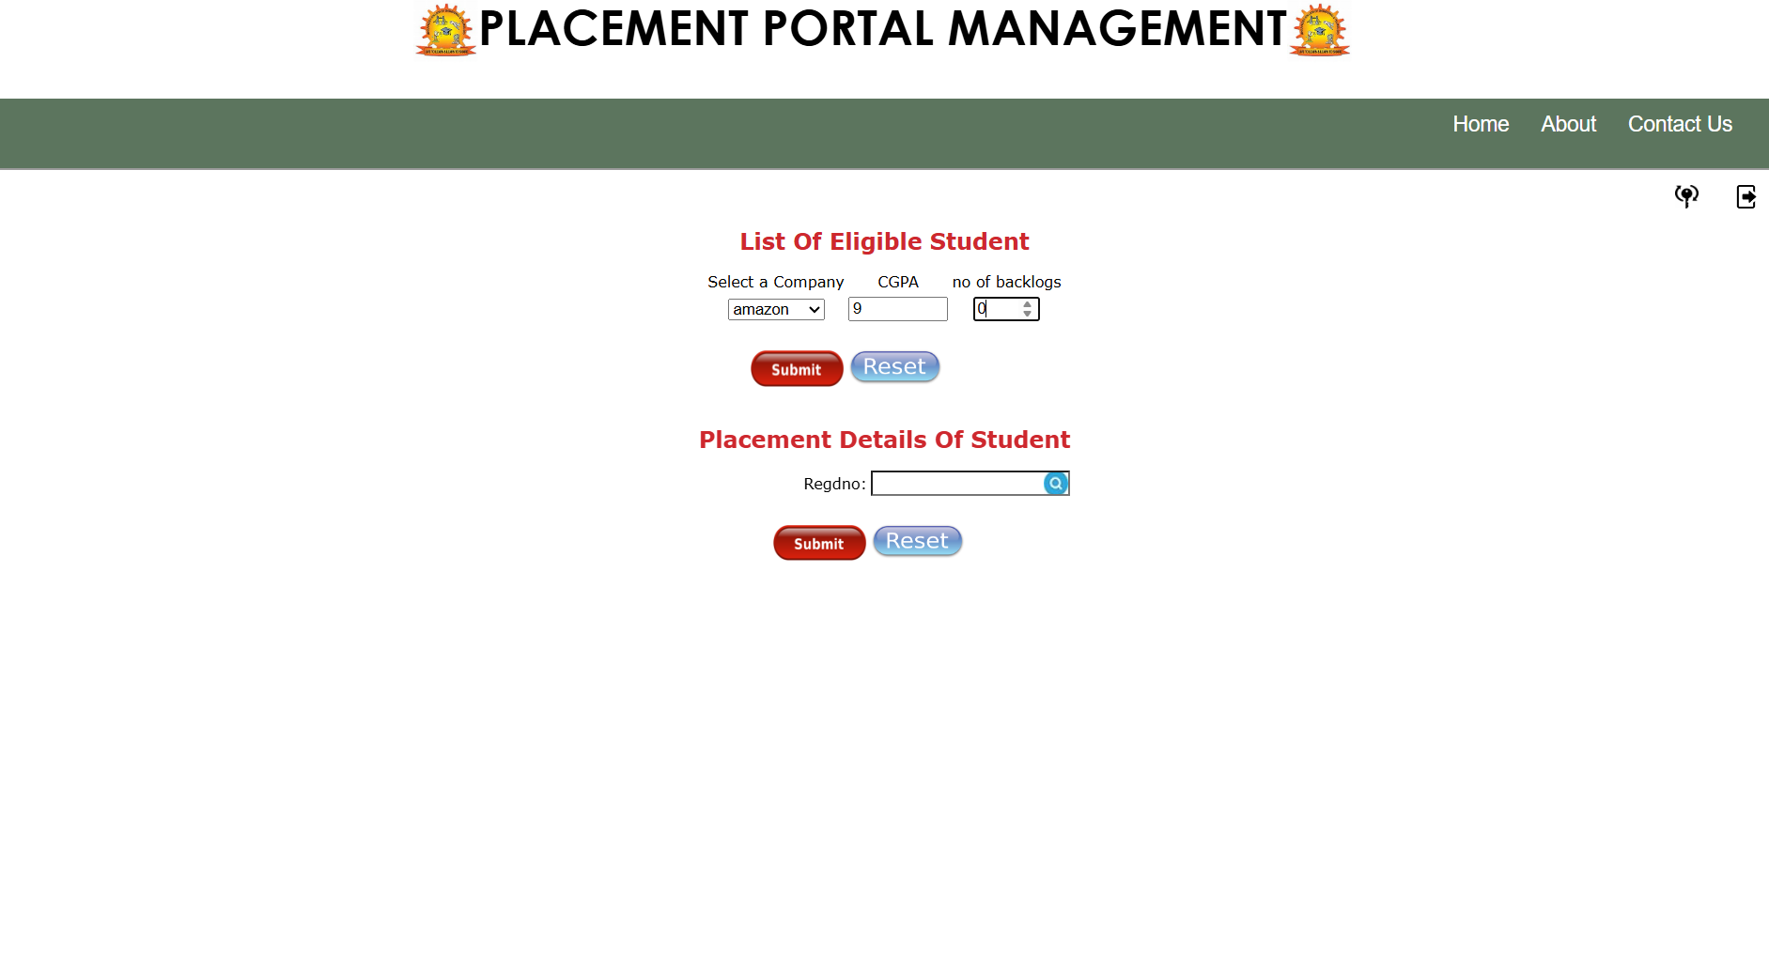

6.3.2.2 Output

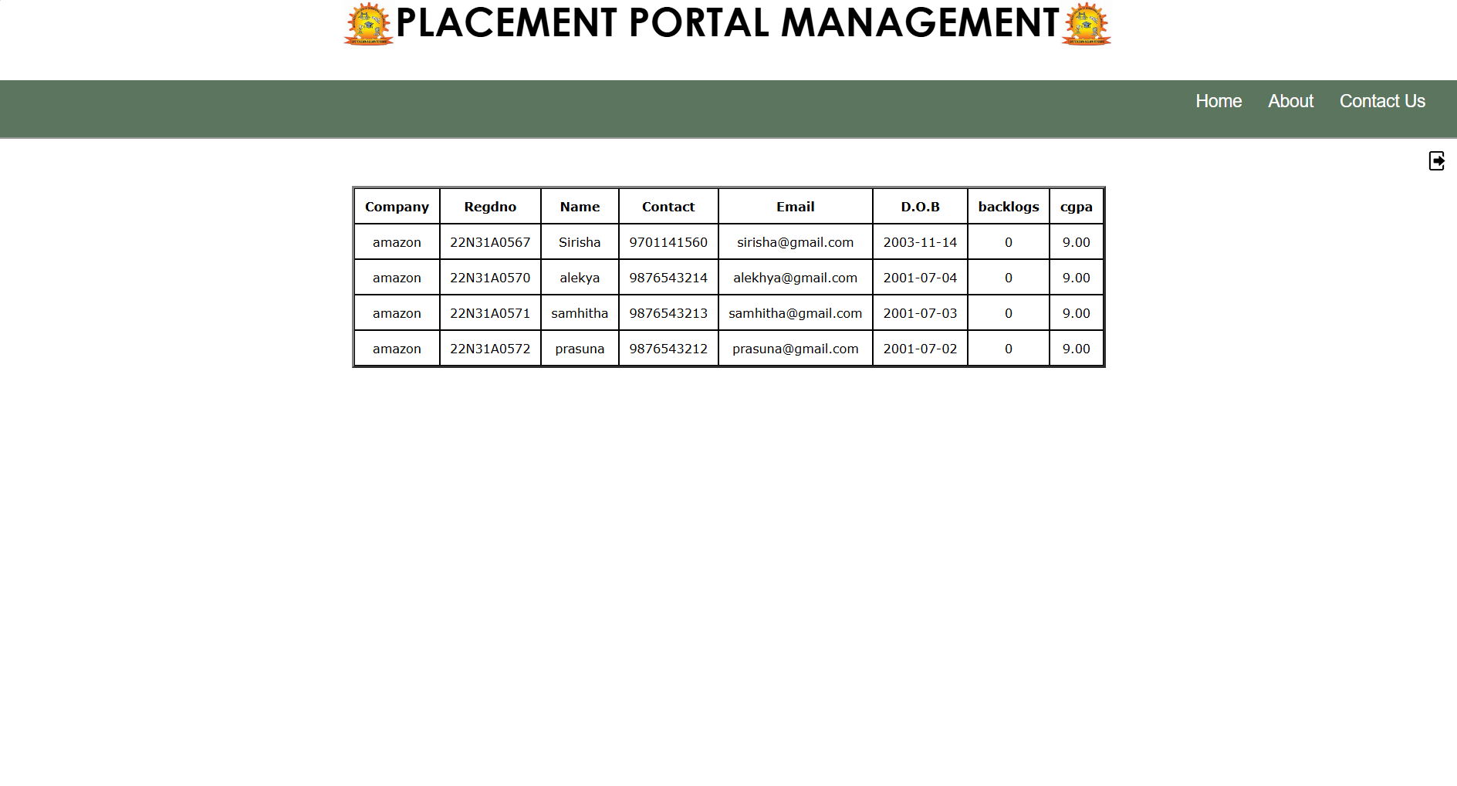

6.3.3 Test Case 3: Checking Student Details

6.3.3.1 Input
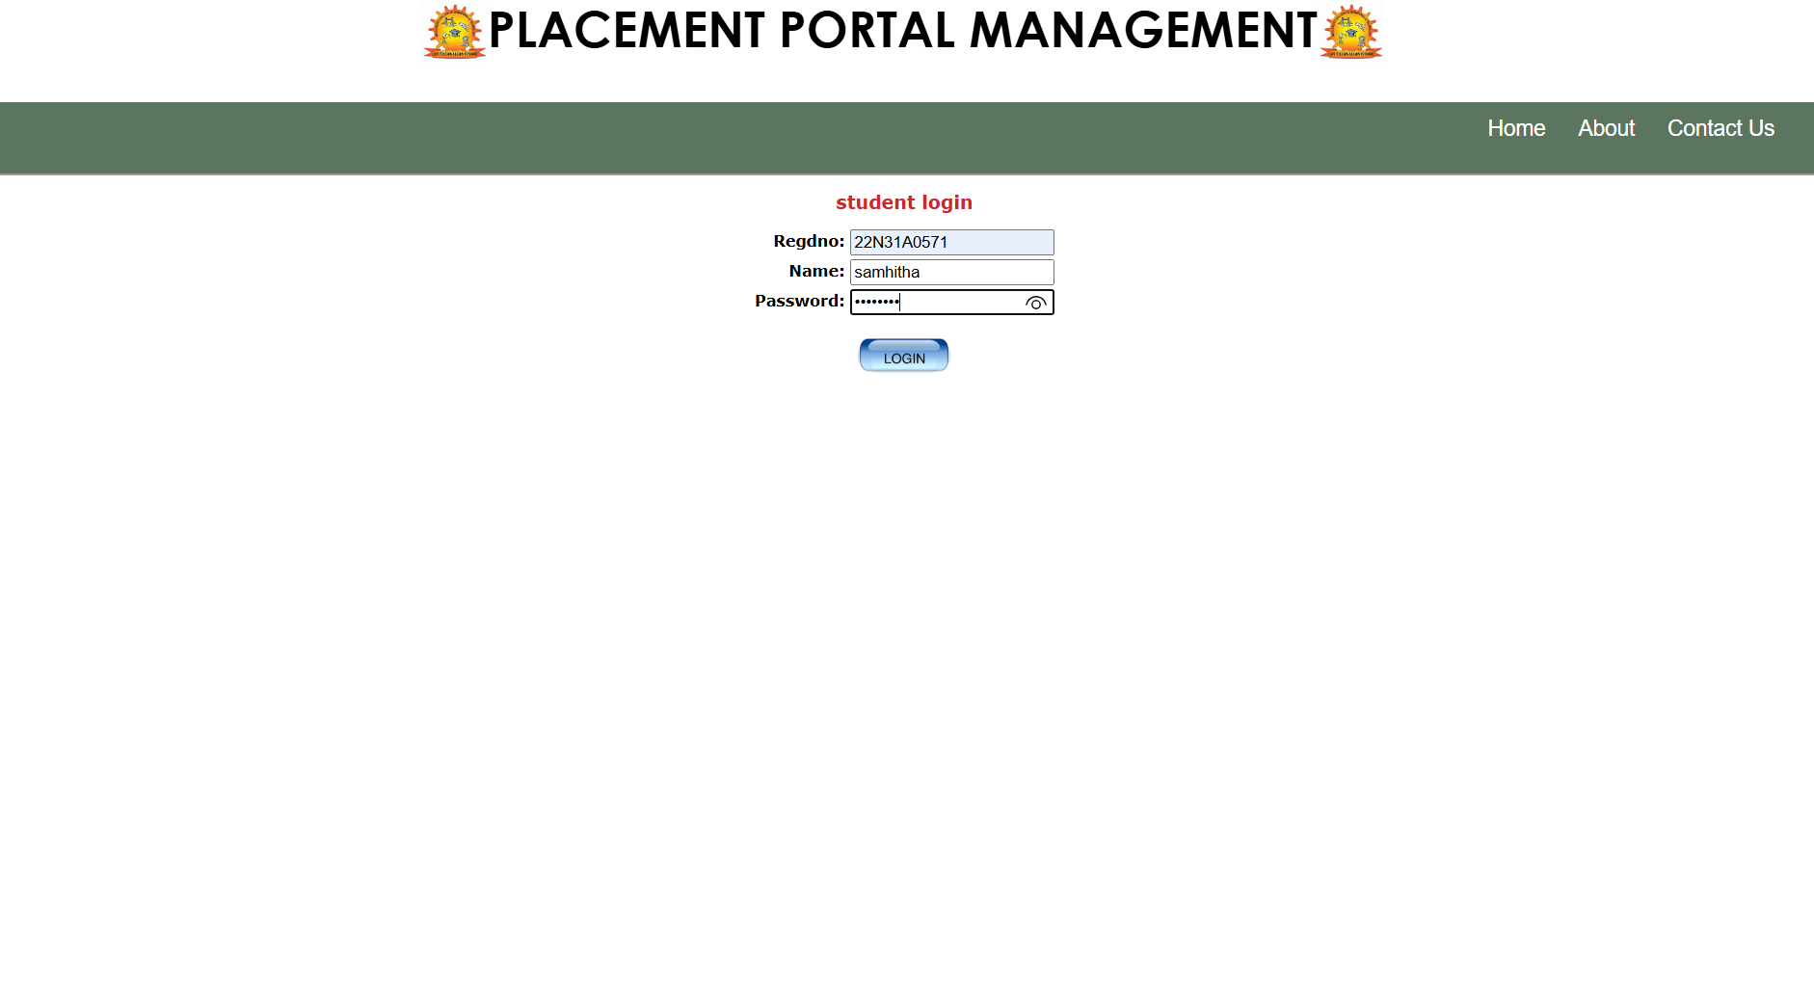

6.3.3.2 Output

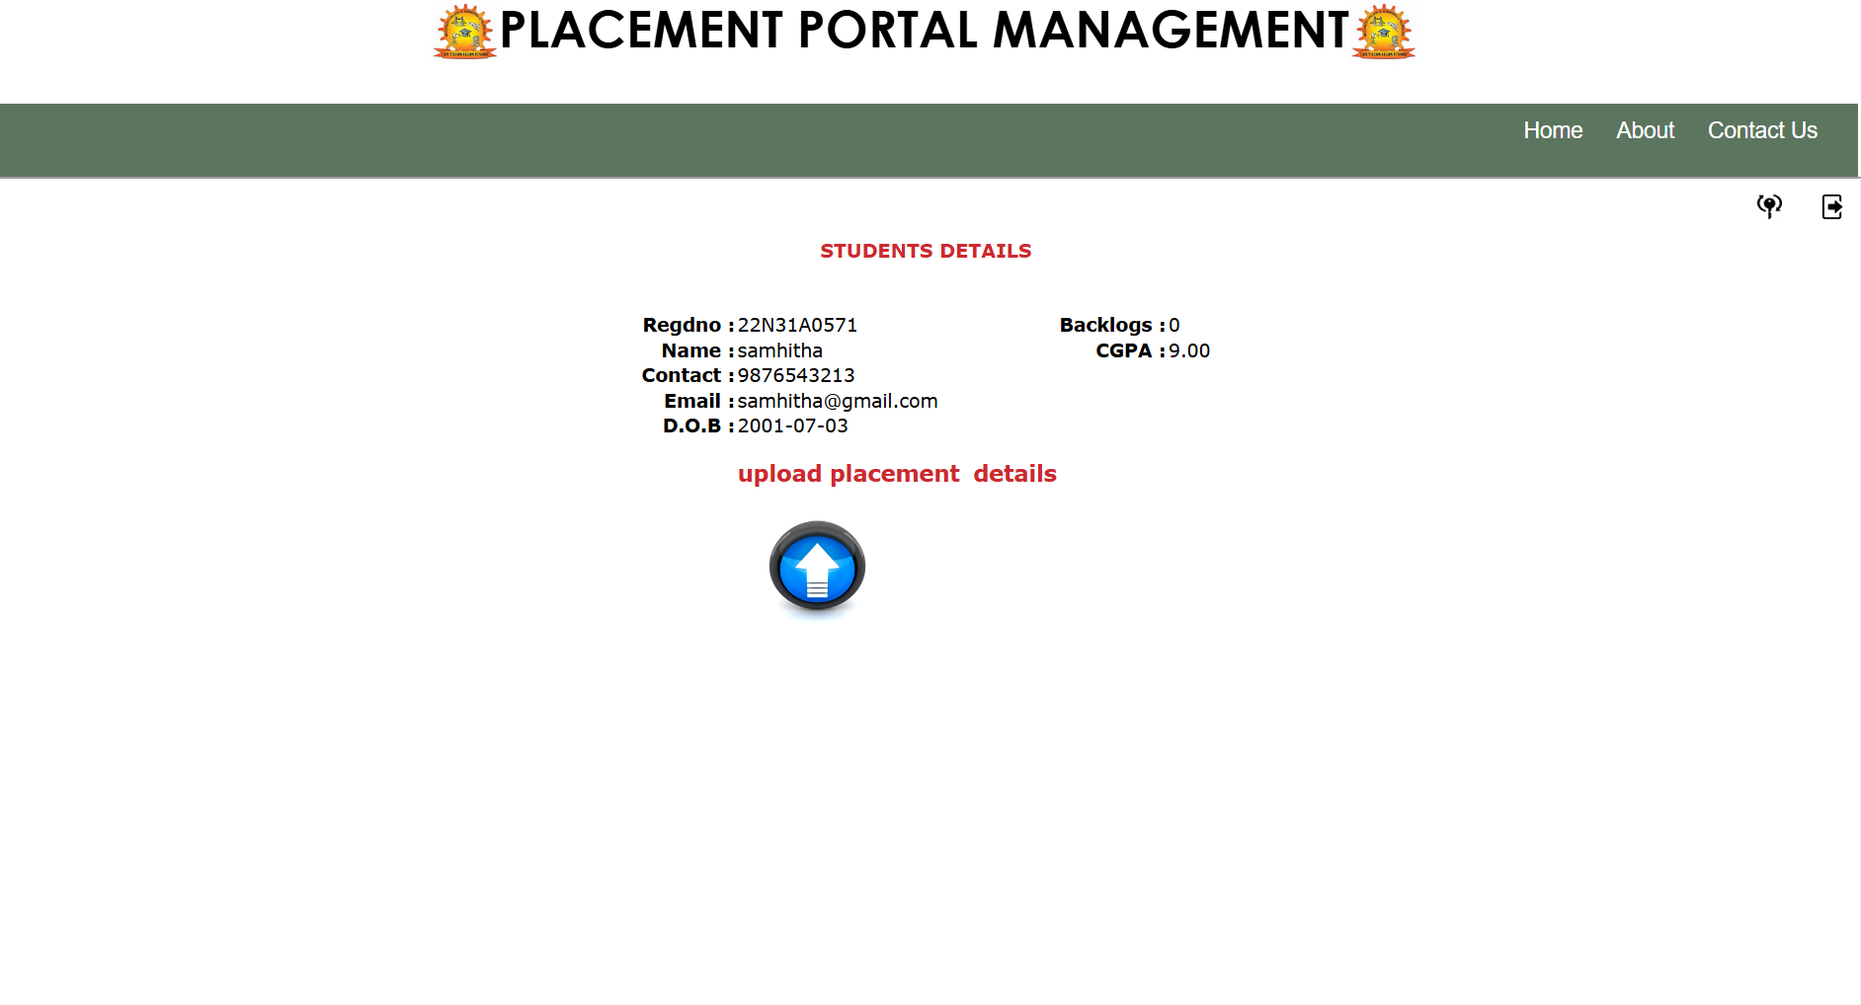
CHAPTER 7

CONCLUSION

In conclusion, the development and implementation of the Placement Portal Management System have significantly enhanced the efficiency of the placement process within educational institutions. By automating critical tasks and providing seamless communication between students, staff, and administrators, this web-based application has streamlined operations through its three core modules: Student, Staff, and Admin.

The system leverages PHP and MySQL to ensure smooth data management and user interaction. The Student Module empowers students to actively manage their placement journey, from profile creation and resume uploads to tracking job applications and receiving timely notifications about placement activities. The Staff Module provides faculty and placement officers with the tools to verify student submissions, schedule interviews, and coordinate with recruiting companies, fostering a more organized and transparent process. Meanwhile, the Admin Module offers full control over system operations, enabling administrators to manage roles, permissions, and academic records, while also generating comprehensive reports on placement activities.

The application's success is rooted not only in its technical capabilities but also in its potential to address the increasing demand for efficient, digital-first solutions within educational institutions. By reducing administrative burdens and facilitating smooth interactions, the Placement Portal Management System enhances the overall placement experience for all stakeholders.

CHAPTER 8

BIBLIOGRAPHY

1. T. Kumar, S. Sharma, and P. Singh, "Streamlining Placement Processes in Higher Education Using Web-Based Platforms," 2022 Journal of Computer Applications in Education, vol. 45, no. 2, pp. 98-105, doi: 10.1016/j.jcae.2022.101235.

2. A. Gupta, R. Pandey, and S. Verma, "Efficient Student and Company Coordination through Digital Portals in Campus Recruitment," 2023 IEEE Conference on Innovations in Web Applications, pp. 230-238, doi: 10.1109/CIWA2023.8971234.

3. J. Williams and T. Brown, “Automation of Placement Activities Using Web Technologies: An Overview,” 2020 Journal of Information Systems and Web Development, vol. 32, no. 4, pp. 455-460, doi: 10.1016/j.jisd.2020.101234.

4. S. Rao and V. Chakraborty, "Database Management in Education Sector: Using MySQL for Enhanced Performance," 2021 International Journal of Database Technologies, vol. 29, no. 3, pp. 112-120, doi: 10.1109/IJDT2021.654321.

5. P. Reddy and V. Kumar, "Enhancing Campus Placement through Automated Web Portals: A Case Study Using PHP and MySQL," 2023 International Journal of Educational Technology Solutions, vol. 18, no. 5, pp. 78-85, doi: 10.1016/j.ijets.2023.101248.

6. K. Patel and S. Desai, "Optimizing Student Placement Processes through Web-Based Management Systems," 2022 International Conference on Web-Based Innovations in Education (ICWIE), pp. 320-327, doi: 10.1109/ICWIE2022.1012543.

